I Paid a Bribe

Introduction

Assignment is about scraping data from the webpage ipaidabribe.com and making an analysis on the data. According to a recent study, corruption is the biggest issue of concern. It is ranked No. 2 by Indians

I Paid a Bribe uses citizen reporting to identify corrupt government services and work with local government to affect process change. It helps the average Indian post his or her bribery experience and it also uncovers the “market price” of corruption in various cities, departments and services.

The way it goes is, that anybody that has to bribe someone in order to get what they want, which could be anything from a FIR and Complaints, Food License, Health Services etc., reports it on the webpage for everyone to see. They report the amount, the location etc.

Approach

The task was to scrape the latest 1000 observations from the webpage and analyze the data.  
I scraped the data using Beautifilsoup.and n loop is created to scrape 1000 reports from 100 pages.

Data analysis

The highest bribe cases recorded in Karnataka i.e.330 cases. There could be another clarification behind this: The organization that runs the site ipaidabribe.com is situated here. This could impact the attention to the individuals living in the area and consequently they will be bound to make a report. . It is particularly reliant on the web get to and the awareness of the webpage.

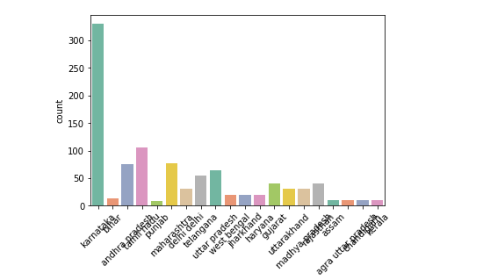

The website does not allow the mention of names.

The largest number of bribe cases (in value) was being reported from Hospitals and Medical Care followed by commercial and industrial project. Interestingly, the bribe for the same work varied from Rs 200000 to Rs 2000000 .n total amount recorded is INR 132000000 and total 84 transaction for the same reason.

Education bribes are taken for certificates

The people may lose trust in the medical community.it is found highest bribe is in kidney transplant costing 20 million bribe amount

There is shockingly a tremendous contrast between them. For another Ticket checker you have to pay, in normal, 100 Indian Rupee , while a duplication of the driving permit is modest with a cost of 500 Indian Rupee (around 52 DKK).

You can lodge FIR bribing average rs2000 .To avoid this all reports, FIR etc. should be registered online.  
One amusing note about it: In request to get a grant in India, it appears that you now and then first need to pay cash, before you recover a few.

It gets 3,000-5,000 hits every day with 1.4 million hits so far. It has 20,000-plus bribe reports filed from 500 Indian cities.

We utilized the influences for a "birth authentication" for instance, on the grounds that there are 20 reports.

We didn't generally expect these large contrasts and it appears, that the outcome aren't generally dependable. In any case, we can neither avow them nor scrap them, since we have something other than a couple of reports on every city. (Kolkata: 20; deharadun: 20, Hyderabad: 20, Mumbai: 20)

It can finish up, that the guide/the site doesn't generally appear, where the most influences in India are. It is particularly subject to the web get to and the awareness of the webpage.

 In any case, it can truly be the situation, that fixes are less normal (and along these lines progressively costly) in the most significant two urban communities Delhi and Mumbai, since they get increasingly national and universal consideration.

*Stop paying bribes. Collectively, when an entire nation decides to do this, the cops will have no option but to stop asking for bribes*.